**TMSP—Local program images and documentation upload for quarterly activity reports.**

**2023 Quarter 1**

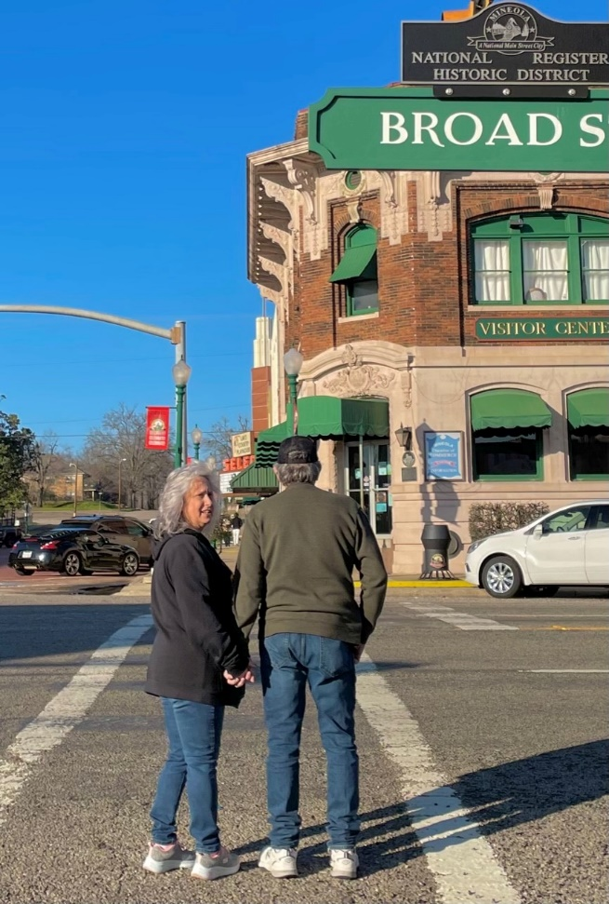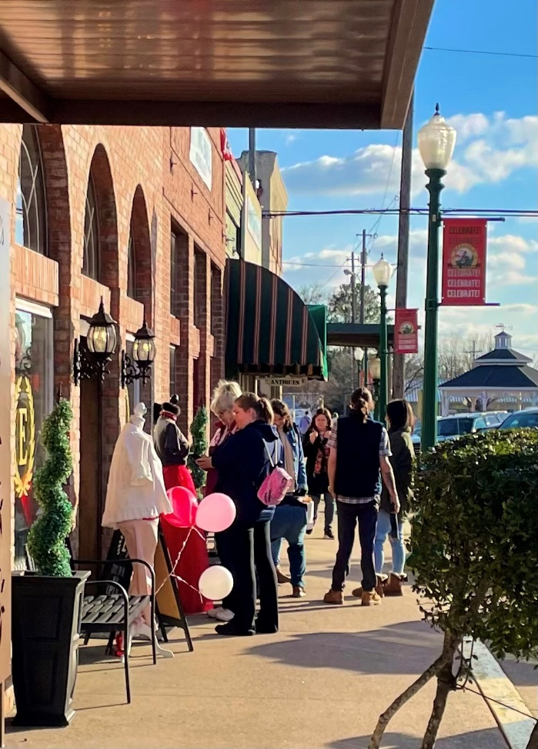

**Our City Marketing and Main Street Programs helped promote a “grassroots” group of downtown merchants hosting a highly popular Couples Night out for Valentines Day. Our merchants do not have an official organization, but organize and work together to host this effort themselves.** s,

**The Historical Museum Board planned for several months for this special program by Mineola native Ruthie Foster. Ruthie provided her performance for free and delivered a soul-stirring performance before an audience of approximately 100 people in the pre-integration Black school gymnasium. Her songs were interspersed with her anecdotes about traveling the world to perform.**

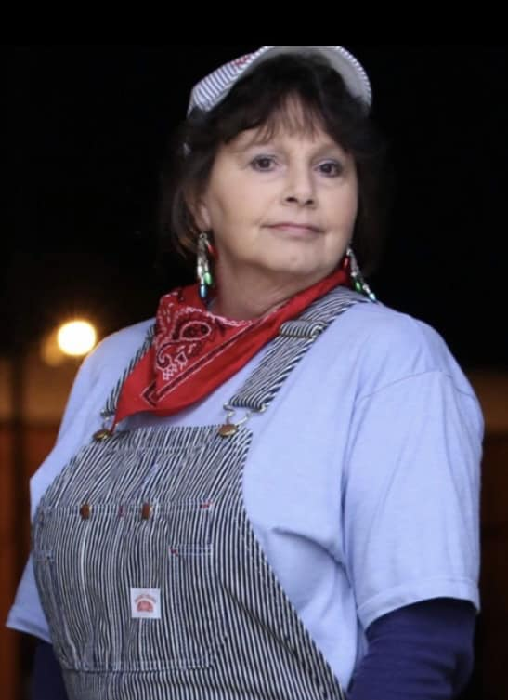This lady, Cheryl Wood, does it all! Yes, she is a certified engineer for the Landmark Commission’s (on which she serves) Mini Train. She provides balloons for send-offs for school students heading to state competitions. She decorates the gazebo for July 4 and our Farmers Market Pavilion for Landmark’s Hobo Stew. She donated flowers, greenery and vases for Main Street’s Dueling Pianos fundraiser this spring. She also serves on the Sesquicentennial Committee and works with many of the sub-committees. She owns and operates a florist shop in downtown. Plus, she and her long-time helper park a block away from their business and walk back and forth to their cars every day! Main Street presented them umbrellas as a thank you for their efforts. Her business exterior was renovated

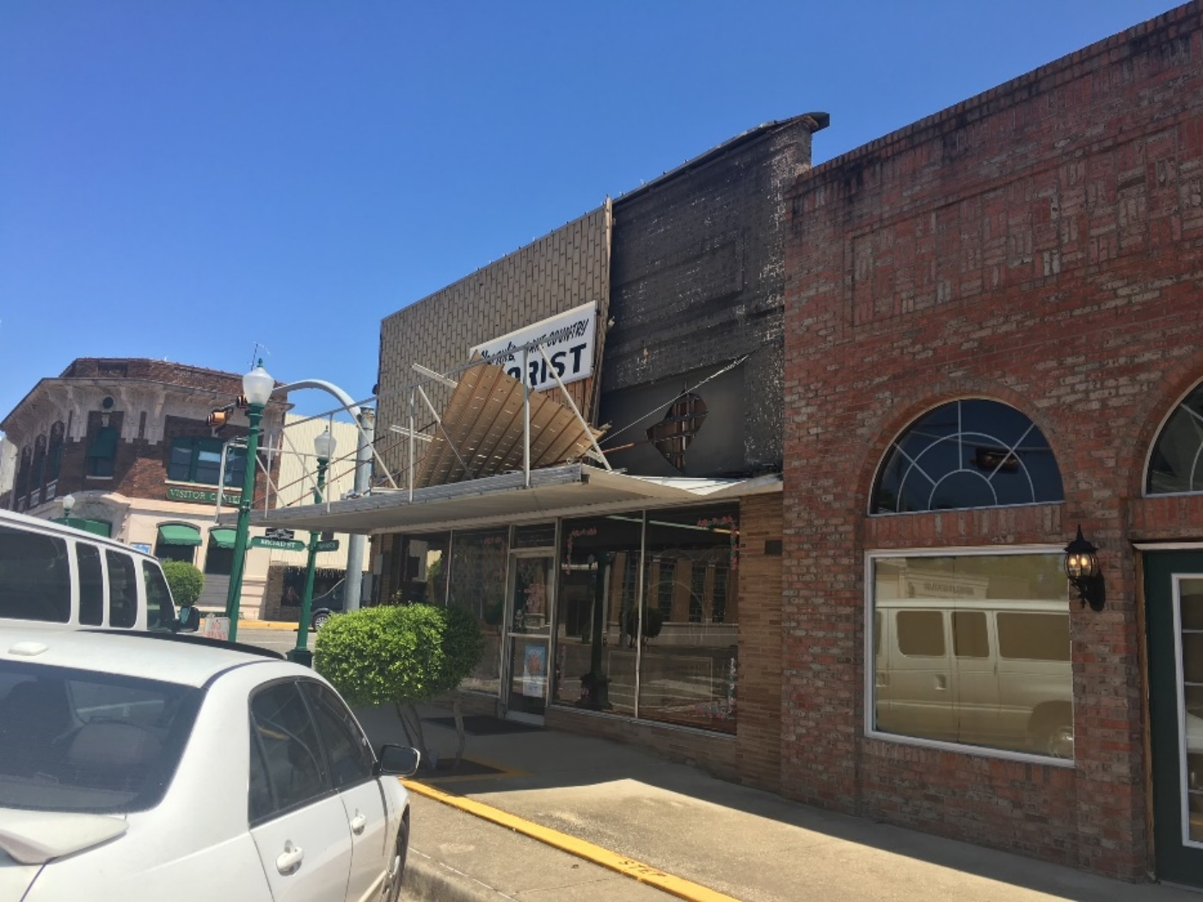

BEFORE: An economic development grant assisted in the exterior rehabilition of Cheryl’s Lake Country Florist. The project was done by a contractor who had retired to the area who had previously restored historic homes in Highland Park – he has a passion for old structures. The owner did not want to go in to debt to do this work but her property is located directly across Highway 80 from our beautiful chamber of commerce. Cheryls is often in the background of Christmas parade photos. Seeing the building rehabbed was a prominent goal of our Main Street, but needs such as a new roof and air conditioning had to come first. So we are elated that the contractor, Dennis Thompson who also did Gene’s Photography project, came along. Even though he and owner Cheryl often disagreed, they worked out the facelift which was to both the 102 East Broad Street side, and South Johnson Street with careful respect to things such as the building elements, brick style and colors of neighboring buildings finally completed this quarter. We are elated to have this property at one of our most important intersections rehabbed.

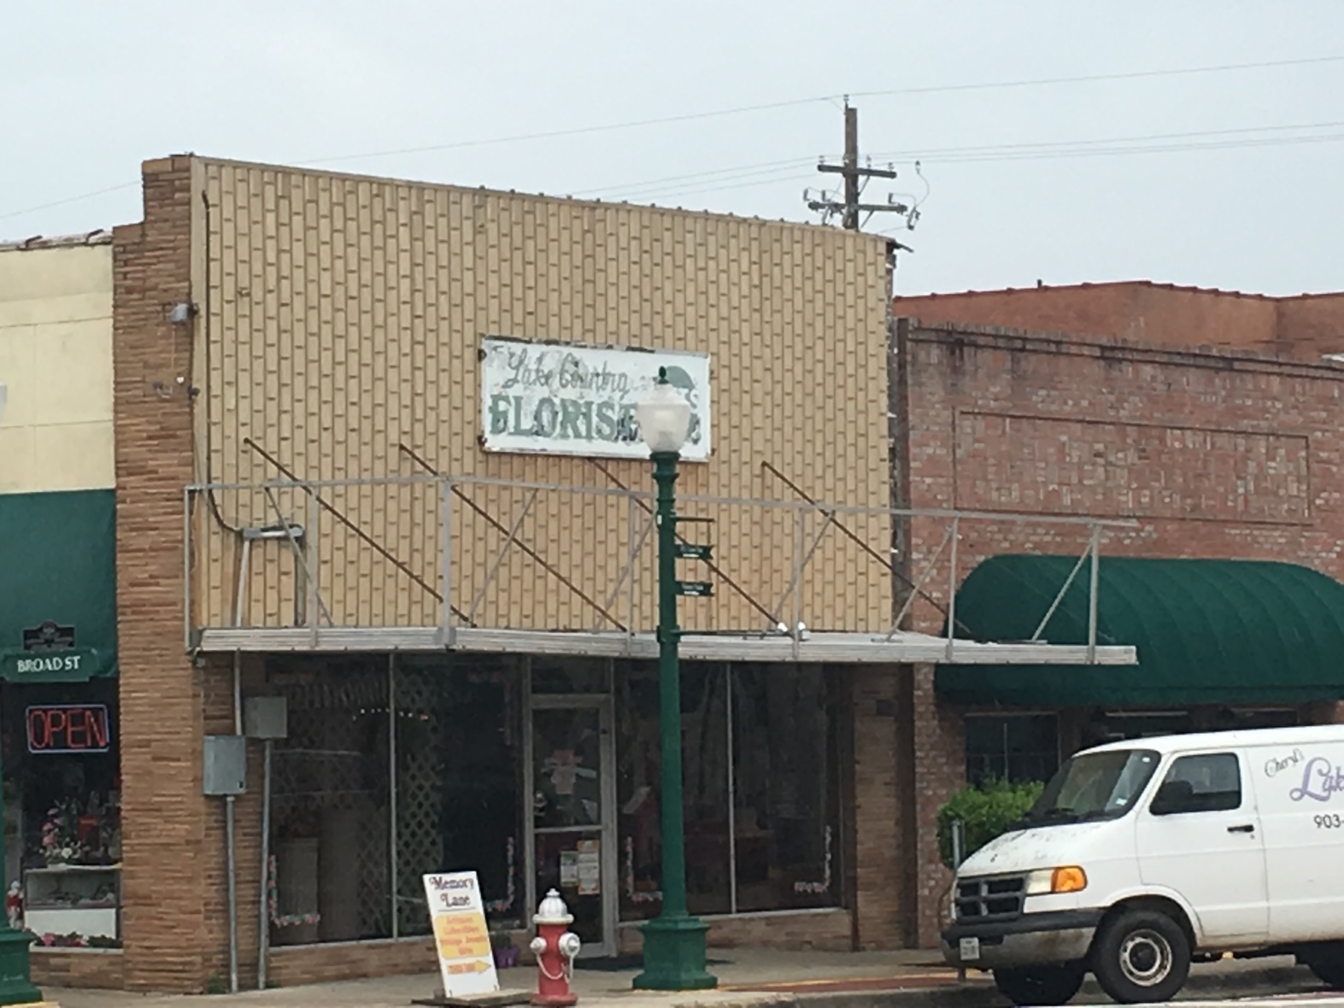

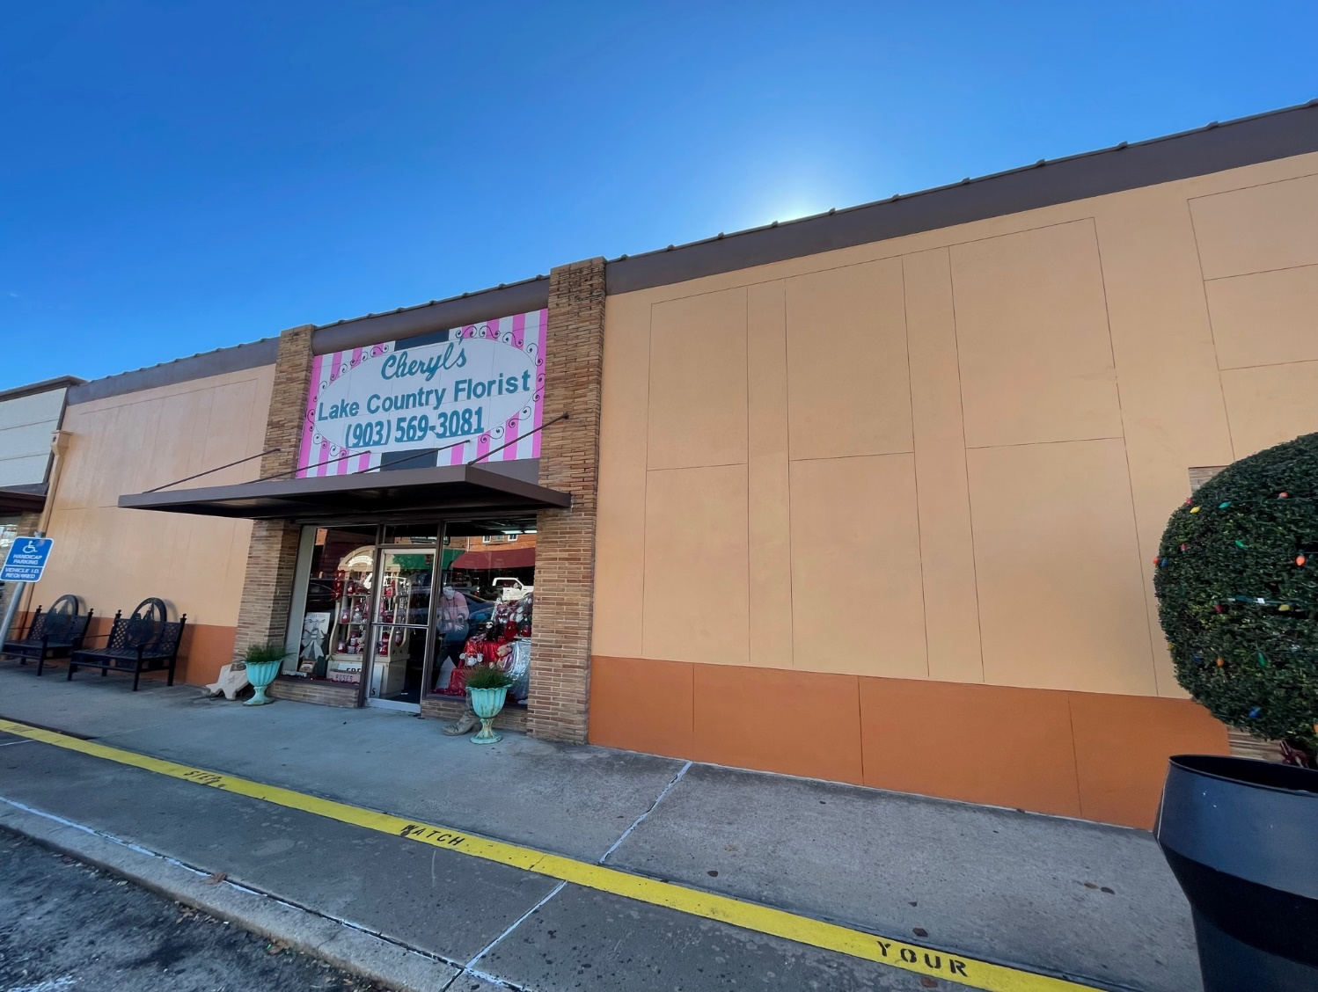

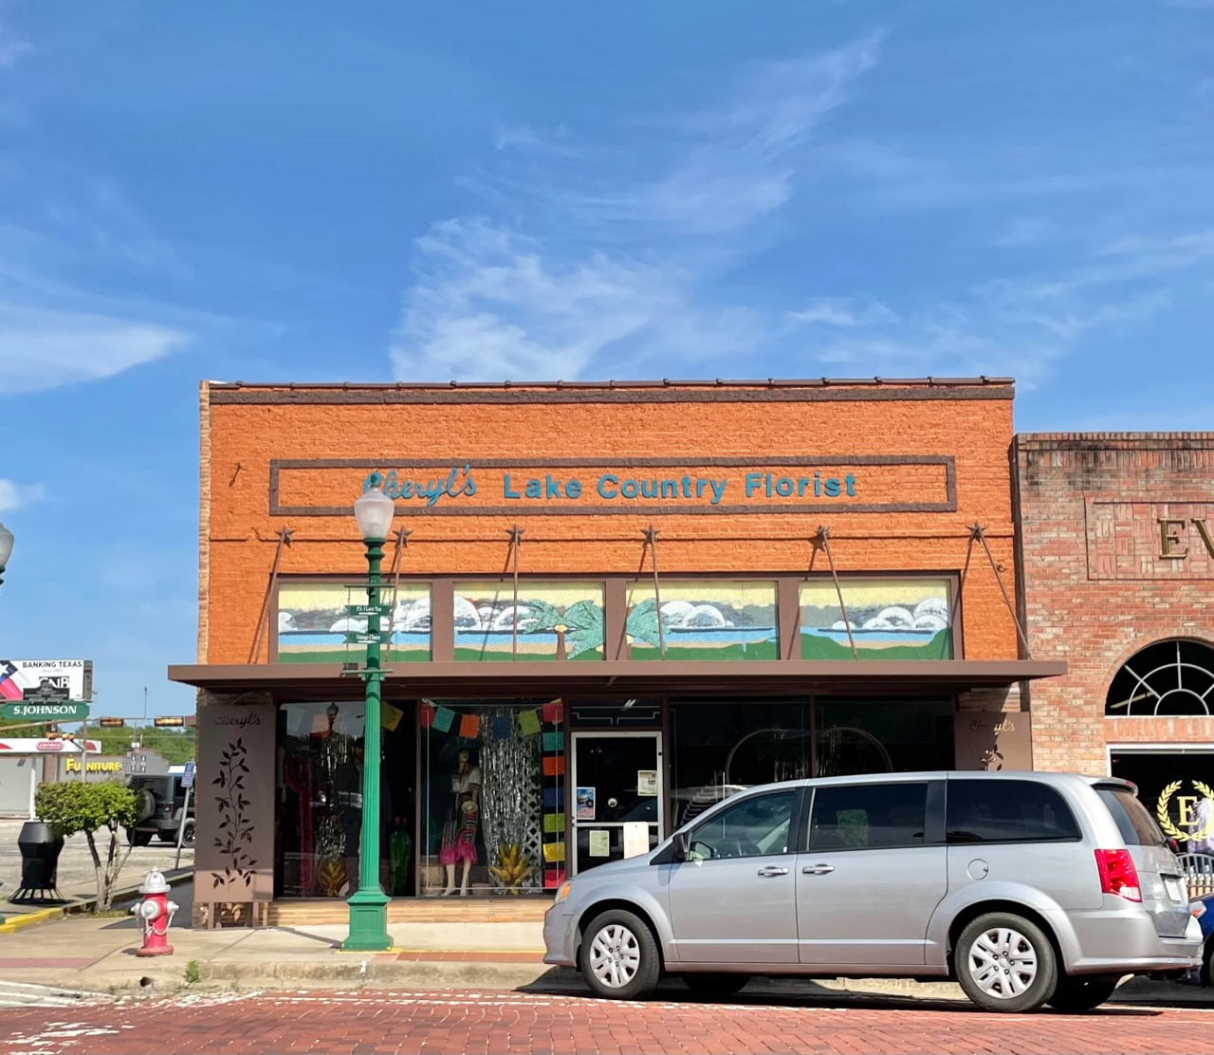

**Community: Mineola Main Street**

**Another wonderful article by our community newspaper, the Wood County Monitor, about our working Amtrack Depot… “Ribbons of Steele.”**

[**https://www.woodcountymonitor.com/stories/connections-through-ribbons-of-steel,162212?fbclid=IwAR1Ryd9J6GeMwdaEgpyTQrQyYkW8tOvf1arjnxf9ZqTTZmTMhfnA9WQVGsM**](https://www.woodcountymonitor.com/stories/connections-through-ribbons-of-steel,162212?fbclid=IwAR1Ryd9J6GeMwdaEgpyTQrQyYkW8tOvf1arjnxf9ZqTTZmTMhfnA9WQVGsM)

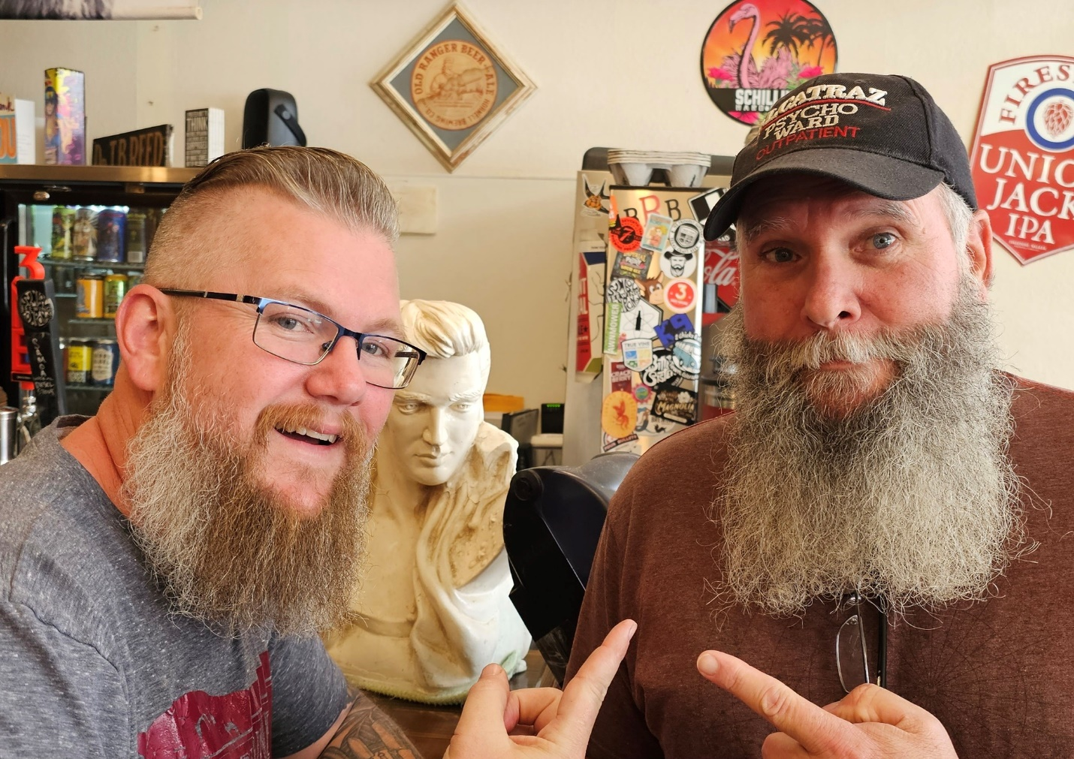 

Main Street Board Member Steve Brooke, right, and Jason Herring, owner of Cowburners, are volunteering to head the Beard Contest to be held May 20 for our Sesquicentennial.

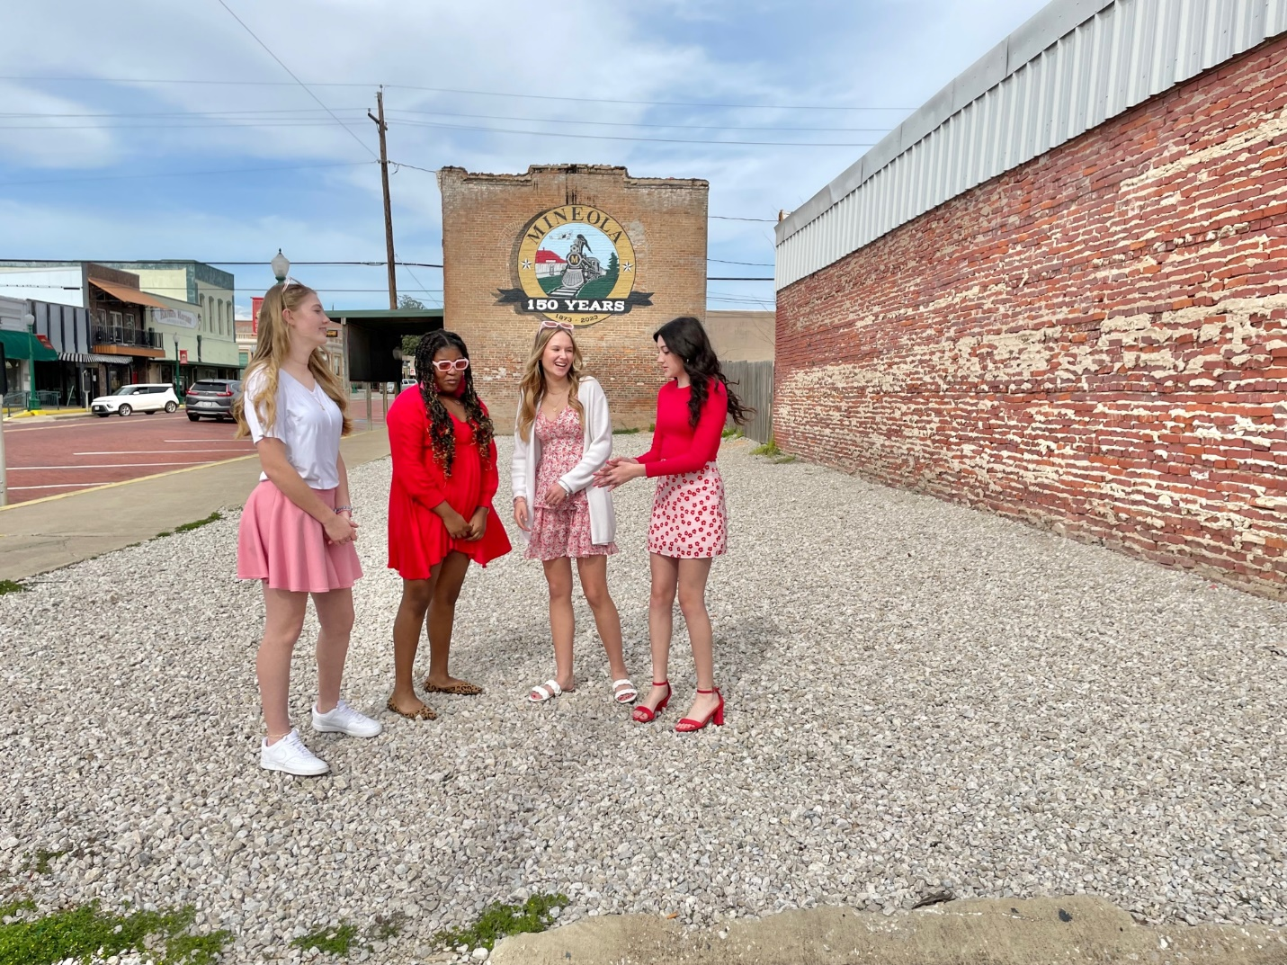

Another photo session taking place with downtown Mineola Main Street as the setting. It’s not an unusual sight.